

MANGU 2025 KCSE PREDICTION
CONFIDENTIAL EXAM
233/2
CHEMISTRY
PAPER 2
TIME: 2 HOURS

NAME……………………………………………………………………………………….
SCHOOL……………………………………………… SIGN………………………..
INDEX NO……………………………………………. ADM NO……………………

(Kenya Certificate of Secondary Education)
INSTRUCTIONS TO CANDIDATES
- Write your name and admission number in the spaces provided above.
- Answer all the questions in the spaces provided in the question paper.
- Non-programmable silent electronic calculators and KNEC mathematical tables may be used.
- All working must be clearly shown where necessary.
- Candidates should answer the questions in English.
For Examiner’s Use Only
QUESTION | MAXIMUM SCORE | CANDIDATE’S SCORE
1 | 12
2 | 13
3 | 11
4 | 11
5 | 12
6 | 10
7 | 11
Total score | 80

1. ( a) Detergents are substances that improves cleansing properties of what. Name two substances that are added to detergents to make them more effective in cleansings. (1mark)
…………………………………………………………………………………………………………
…………………………………………………………………………………………………………

(b) The flow chart below shows steps in the manufacture of soapless detergent. Study it and answer the questions that follow.
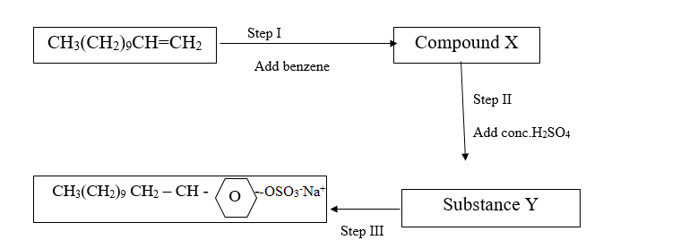
(i) State the condition necessary for Step I. (1mark)
…………………………………………………………………………………………………………
O
(ii) Write an equation for the reaction in step I (benzene, C₆H₆ is represented as). (1 mark)
…………………………………………………………………………………………………………
…………………………………………………………………………………………………………
( c ) (i) Name the process in step III. (1mark)
…………………………………………………………………………………………………………
(ii) Give the reagent in step III. (1mark)
…………………………………………………………………………………………………………
(iii) Give the name of the product of step III. (1mark)
…………………………………………………………………………………………………………
(d) Explain:
(i) One advantage of soapless detergents over soaps. (1mark)
…………………………………………………………………………………………………………
…………………………………………………………………………………………………………

(ii) One disadvantage of soapless detergents over soaps. (1mark)
…………………………………………………………………………………………………………
(e) Pentanoic acid reacts with butan-1-ol to form an organic compound.
(i) What is the name given to the above type of reaction? (1mark)
…………………………………………………………………………………………………………
(ii) A certain catalyst must be added to the mixture to increase the rate of reaction.
Name the catalyst. (1mark)
…………………………………………………………………………………………………………
Explain the role of the catalyst in the above reaction. (1 mark)
…………………………………………………………………………………………………………
…………………………………………………………………………………………………………

- Study the structure below and use it to answer the questions that follows
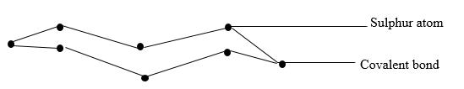
( a ) State two observations made when the molecule is heated to a temperature of 113ºc. (2 mks)
…………………………………………………………………………………………………………
…………………………………………………………………………………………………………

(b) Write an equation of the reaction between sulphur atom with hydrogen gas. (1mark)
…………………………………………………………………………………………………………
(c) Below is a flow chart. Use it to answer the questions that follow.
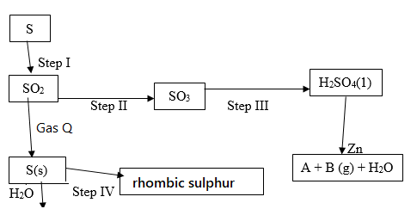

Name: (2 marks)
(i) Gas Q ……………………………………….
(ii) Gas B …………………………………….

( d ) (i) State the observations made in step I. (2marks)
…………………………………………………………………………………………………………
…………………………………………………………………………………………………………
…………………………………………………………………………………………………………

(ii) Step I and Step II occur in the Contact process. State the optimum conditions necessary for Step II to occur. (2marks)
…………………………………………………………………………………………………………
…………………………………………………………………………………………………………
…………………………………………………………………………………………………………

(iii) Name the reagent used in Step IV. (1 mark)
…………………………………………………………………………………………………………

(iv) Explain why water is not used in Step III. (1 mark)
…………………………………………………………………………………………………………
…………………………………………………………………………………………………………

(e) Sulphur (iv) oxide is a major environmental pollutant and should not be emitted into the atmosphere. Name the reagent used to achieve this. (1 mark)
…………………………………………………………………………………………………………

(f) Explain the role of Sulphur in vulcanization of rubber. (1 mark)
…………………………………………………………………………………………………………
…………………………………………………………………………………………………………

3. Study the Standard electrode potential for the half-cell given below and use it to answer the questions that follow. The letters do not represent the actual symbols of elements.
E0 (volts)
P⁺ _{(aq)} + e⁻ P(s) | -2.92
Q⁺ _{(aq)} + e⁻ Q (s) | +0.52
R⁺ _{(aq)}+ e⁻ ½R₂ (g) | 0.00
S²⁺_{(aq)} + 2e⁻ S(s) | -0.44
½T_{2 (g)} + e⁻ T⁻_{(aq)} | +1.36
(a) Identify the strongest oxidizing agent. Give a reason for your answer. (2 marks)
…………………………………………………………………………………………………………
…………………………………………………………………………………………………………
…………………………………………………………………………………………………………

( b ) Which half cells would produce the highest potential difference when combined? (1 mark)
…………………………………………………………………………………………………………
…………………………………………………………………………………………………………

( c ) Predict whether the reaction represented below can take place. (2 marks)
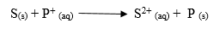
…………………………………………………………………………………………………………
…………………………………………………………………………………………………………
…………………………………………………………………………………………………………
…………………………………………………………………………………………………………

(d)Write a cell representation for the cell that would be constructed by combining P and Q. (2 mks)
…………………………………………………………………………………………………………
…………………………………………………………………………………………………………
…………………………………………………………………………………………………………
…………………………………………………………………………………………………………

(e) 100 cm³ of 2M sulphuric acid was electrolyzed using the set up represented by the following
diagram.
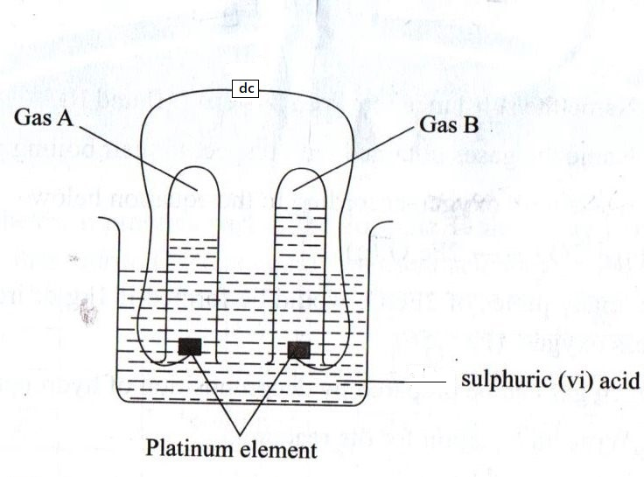
(i) Write an equation for the reaction that produces gas B.
…………………………………………………………………………………………………………
…………………………………………………………………………………………………………

(ii) Describe how gas A can be identified. (1 mark)
…………………………………………………………………………………………………………
…………………………………………………………………………………………………………

(iii) Explain the differences in the volumes of gases produced at the electrodes. (2 marks)
…………………………………………………………………………………………………………
…………………………………………………………………………………………………………
…………………………………………………………………………………………………………

(f) An electric current is passed through a solution for 18 minutes. The volume of gas produced
at the cathode is 480 cm3.Calculate the current used. (Molar gas volume at rtp = 24 dm3 IF = 96500 C) (2 marks)
…………………………………………………………………………………………………………
…………………………………………………………………………………………………………
…………………………………………………………………………………………………………
…………………………………………………………………………………………………………

4. In an experiment, dry hydrogen chloride gas was passed through heated iron wool as shown in the diagram below. The gas produced was then passed through heated lead (II) oxide.
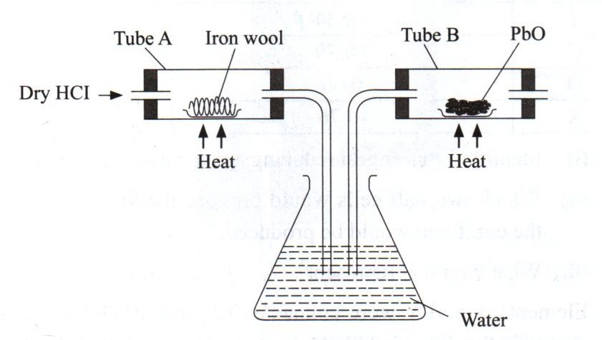
(a) (i) State the function of water in the flask. (1 mark)
……………………………………………………………………………………………………
(ii) Write the equation for the reactions that took place in tubes labeled A and B. (2 marks)
Tube A
…………………………………………………………………………………………………
Tube B
…………………………………………………………………………………………………

(iii) Explain how the total mass of tube B and its contents would compare before and after the experiment. (2 marks)
…………………………………………………………………………………………………………
…………………………………………………………………………………………………………
…………………………………………………………………………………………………………
…………………………………………………………………………………………………………

(b) Chlorine gas and hydrogen chloride gas can be prepared using the following reagents: sodium chloride, concentrated Sulphuric (VI) acid and potassium manganate (VII) and hydrochloric
acid.
(i) State the role of each of the following in the reaction. (1 mark)
Concentrated Sulphuric (vi) acid
…………………………………………………………………………………………………………
…………………………………………………………………………………………………………

Potassium manganate VII. (1 mark)
…………………………………………………………………………………………………………
…………………………………………………………………………………………………………

(ii) Name the bleaching agent formed when chlorine gas is passed through cold dilute sodium hydroxide solution. (1 mark)
…………………………………………………………………………………………………………

(iii) Apart from bleaching action, state the other use of compound formed in (ii) above. (1 mark)
…………………………………………………………………………………………………………
…………………………………………………………………………………………………………

(c) 1.9 g of magnesium chloride were dissolved in water. Silver nitrate solution was then added until in excess. Calculate the mass of AgNO₃ that was needed for the complete reaction. (2 marks) (Ag = 108, O = 16, N = 1, Mg = 24, Cl = 35.5)
…………………………………………………………………………………………………………
…………………………………………………………………………………………………………
…………………………………………………………………………………………………………
…………………………………………………………………………………………………………

5. Use the grid below to answer the questions that follow (the letters do not represent the actual symbols of the elements)
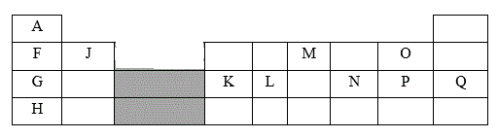
(a) Give the family name to which elements in the shaded area belong. (1 mark)
…………………………………………………………………………………………………………

(b) State and explain the difference in reactivity between G and J. (2 marks)
…………………………………………………………………………………………………………
…………………………………………………………………………………………………………
…………………………………………………………………………………………………………

(c) How does the atomic radius of K compare to that of L? Explain. (2 marks)
…………………………………………………………………………………………………………
…………………………………………………………………………………………………………
…………………………………………………………………………………………………………

(d) Element R forms an oxide of formula RO₂ and it belongs to period 2. Indicate on the grid the position of R. (1mark)
(e) Give the formula of the compound formed between K and P. (1mark)
…………………………………………………………………………………………………………

(f) Give the type of bond formed when F reacts with O. Explain. (2 marks)
…………………………………………………………………………………………………………
…………………………………………………………………………………………………………
…………………………………………………………………………………………………………

(g) Give the electronic arrangements of the ions of G and M. (1mark)
G…………………………………………………………………………………………
M…………………………………………………………………………………………

h) Element A can fit in two groups. Name the two groups and explain. (2 marks)
…………………………………………………………………………………………………………
…………………………………………………………………………………………………………
…………………………………………………………………………………………………………

6. An experiment was carried out using the apparatus as shown below to prepare a sample of nitrogen gas from air.
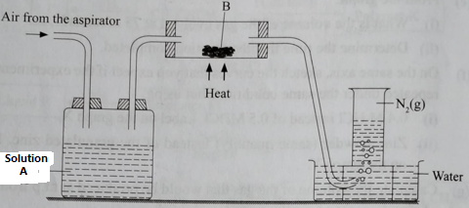
(a) Identify one mistake in the setup. (1mark)
…………………………………………………………………………………………………………
…………………………………………………………………………………………………………

(b) Name what is contained in: (2marks)
(i) Bottle A ……………………………………………..
(ii) Tube B ………………………………
(c) The nitrogen prepared by his method is denser than nitrogen prepared by fractional distillation of liquid air. Explain. (1mark)
…………………………………………………………………………………………………………
…………………………………………………………………………………………………………

(d) Use the flow diagram to answer the questions
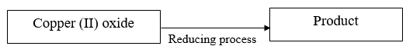
(i) Give the formulae of three gases which can reduce hot copper (II) oxide. (3 marks)
…………………………………………………………………………………………………………
…………………………………………………………………………………………………………
…………………………………………………………………………………………………………
…………………………………………………………………………………………………………

(ii) Explain what will be observed when the above reaction takes place. (1 mark)
…………………………………………………………………………………………………………
…………………………………………………………………………………………………………
…………………………………………………………………………………………………………

(e) In the Haber process, the optimum yield of ammonia is obtained when a temperature of 450ºc,a pressure of 200 atmospheres and an iron catalyst are used.
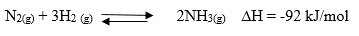
How is the yield of ammonia affected if the temperature is raised to 600º C. Give a reason?(2mks)
…………………………………………………………………………………………………………
…………………………………………………………………………………………………………
…………………………………………………………………………………………………………

7. The flow chart below illustrates extraction of Zinc from zinc blende. Study it and answer the questions that follow 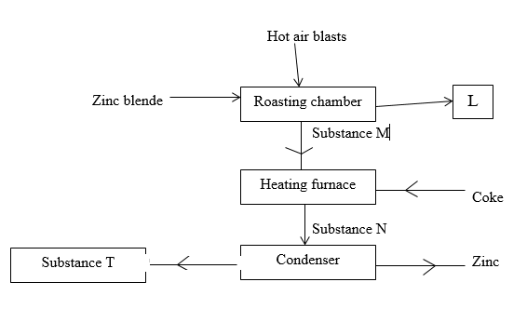
(a) Give an equation for the reaction in roasting furnace. (1 mark)
…………………………………………………………………………………………………………
…………………………………………………………………………………………………………

(b) Name each of the substances marked L and N. (2 marks)
…………………………………………………………………………………………………………
…………………………………………………………………………………………………………
(c) Why is it necessary to condense substance N? (1 mark)
…………………………………………………………………………………………………………
…………………………………………………………………………………………………………
(d) Which other factory can be set up near the zinc extraction plant. Explain. (2marks)
…………………………………………………………………………………………………………
…………………………………………………………………………………………………………
(e) Give one use of zinc metal. (1 mark)
…………………………………………………………………………………………………………

( f ) (i) Zinc sulphide and sulphuric acid react according to the following equation.:
2.91g of zinc sulphide reacted with 100cm³ of 0.2M Sulphuric acid. Determine the reagent that was
in excess. (Zn = 65.0, S = 32.0). (2 marks)
…………………………………………………………………………………………………………
…………………………………………………………………………………………………………
…………………………………………………………………………………………………………
…………………………………………………………………………………………………………

(ii) Calculate the volume of hydrogen sulphide H₂ S ) gas produced in the reaction above at rtp.
Molar gas volume 24 dm³) (2 marks)
…………………………………………………………………………………………………………
…………………………………………………………………………………………………………
…………………………………………………………………………………………………………
…………………………………………………………………………………………………………

This is the last printed page.

